**Chapter 6**

**Database Design**

***6.1 Introduction***

Databases are used for storing, maintaining and accessing any sort of data. They collect information on people, places or things. That information is gathered in one place so that it can be observed and analyzed. Databases can be thought of as an organized collection of information.

The purpose of database design for the Family Planning Office is to create efficient way of handling large amounts and multiple types of data, easy access of information, categorizing data and to create an organized working environment.

***6.2 Database for human resource***

To gather all information related to human resources, several types of data is needed. These are categorized into several tables in our proposed database for human resource. This makes collecting, accessing and querying very easy. Name of the tables are given in *figure 6.1*.

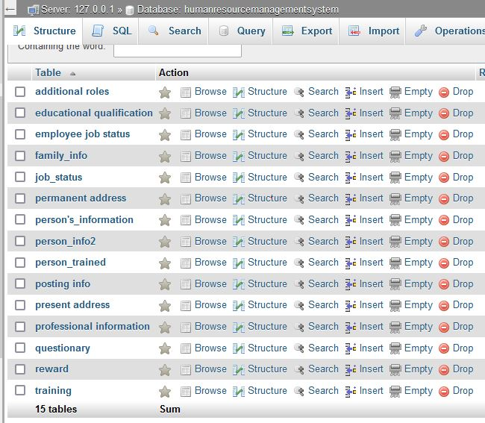

*Figure 6.1 Tables of Human Resource Database*

**6.2.1 Entity relationship diagram for human resource**

An Entity Relationship (ER) Diagram is a type of flowchart that illustrates how entities relate to each other within a system.

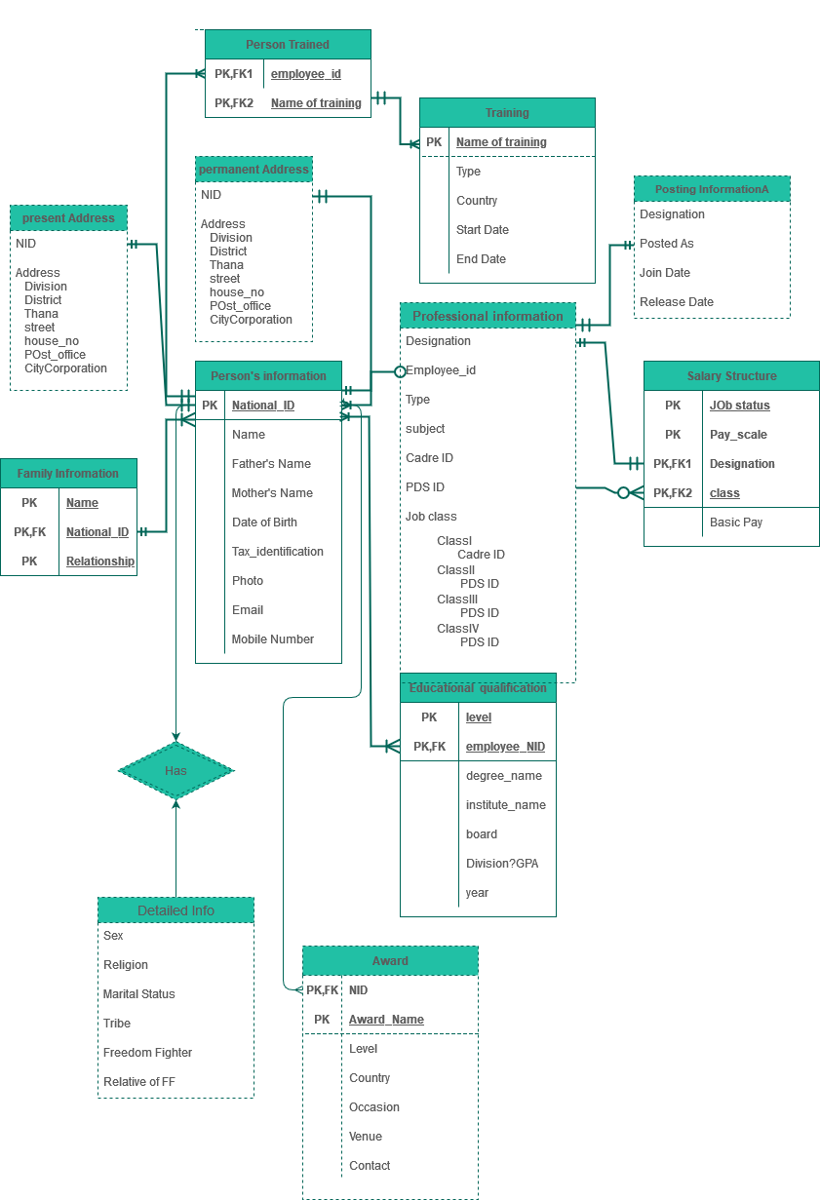

*Figure 6.2 Entity Relationship diagram of Human Resource Database*

**6.2.2 Structure of tables in human resource**

The structure of each table of the human resource database are shown in the figures below.

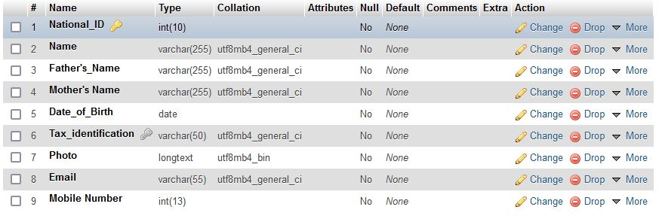

*Figure 6.3 Person’s information Table*

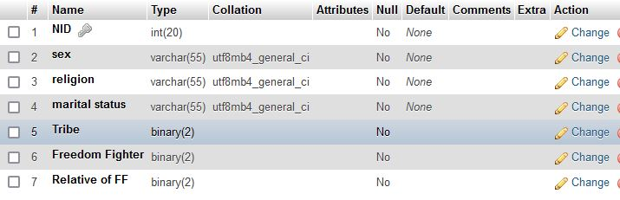

*Figure 6.4 person_info2 Table*

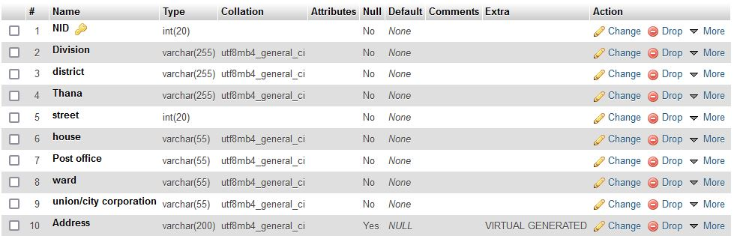

*Figure 6.5 present address Table*

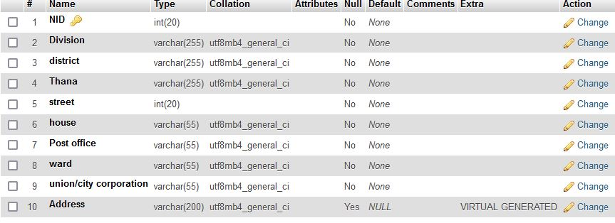

*Figure 6.6 permanent address Table*

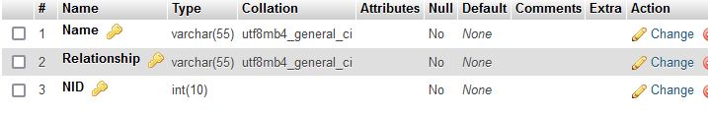

*Figure 6.7 family_info Table*

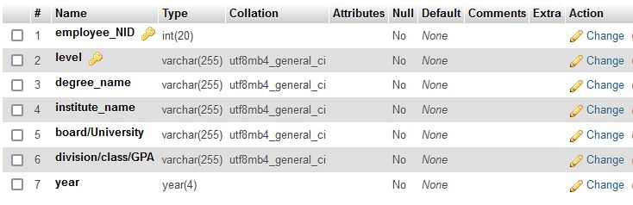

*Figure 6.8 educational qualification Table*

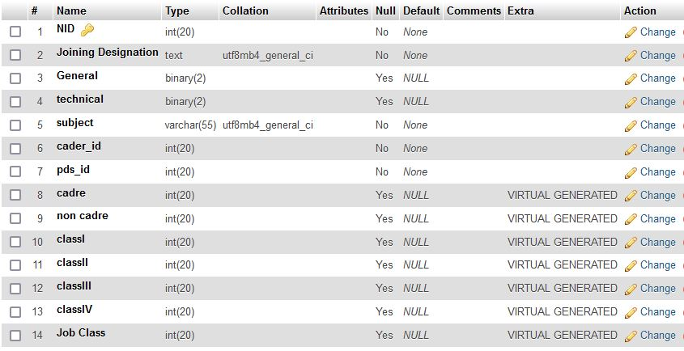

*Figure 6.9 professional information Table*

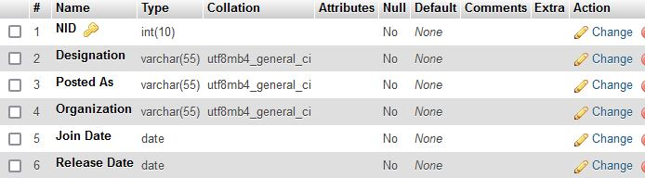

*Figure 6.10 posting info Table*

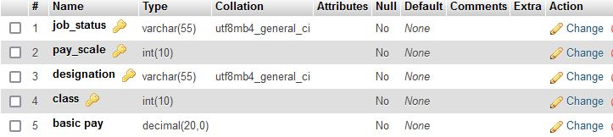

*Figure 6.11 salary structure Table*

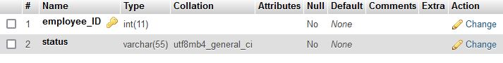

*Figure 6.12 employee job status Table*

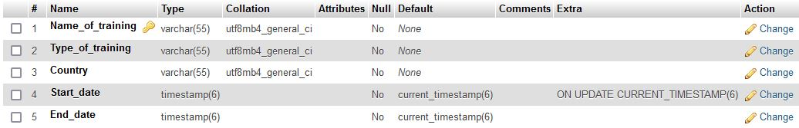

*Figure 6.13 training Table*

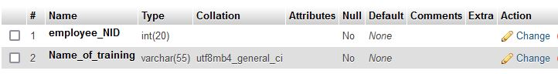

*Figure 6.14 person_trained Table*

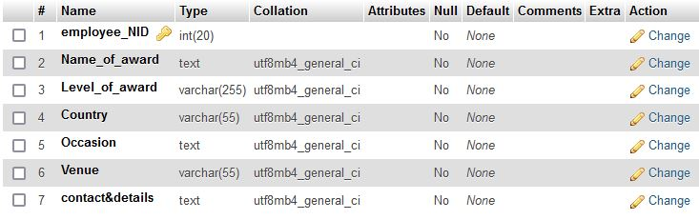

*Figure 6.15 reward Table*

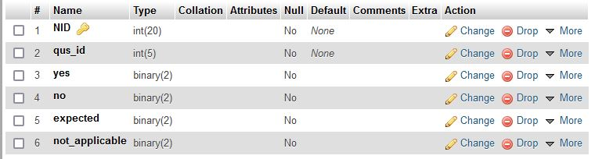

*Figure 6.16 questionary Table*

***6.3 Database for recruitment management system***

To successfully execute recruitment process, monitor them and store information efficiently, several types of data is needed. For collecting, accessing and querying efficiently, there are several tables in this database. Name of the tables are given in *figure 6.17*.

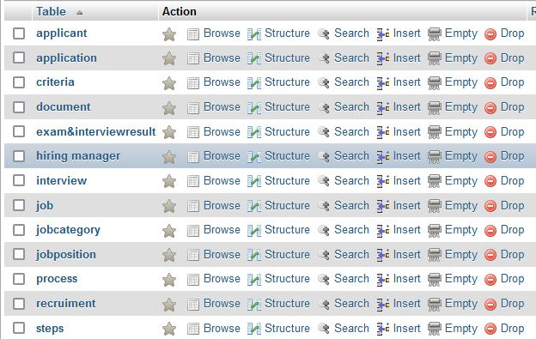

*Figure 6.17 Tables of Recruitment Management Database*

**6.3.1 Entity relationship diagram for recruitment management system**

An Entity Relationship (ER) Diagram is a type of flowchart that illustrates how entities relate to each other within a system.

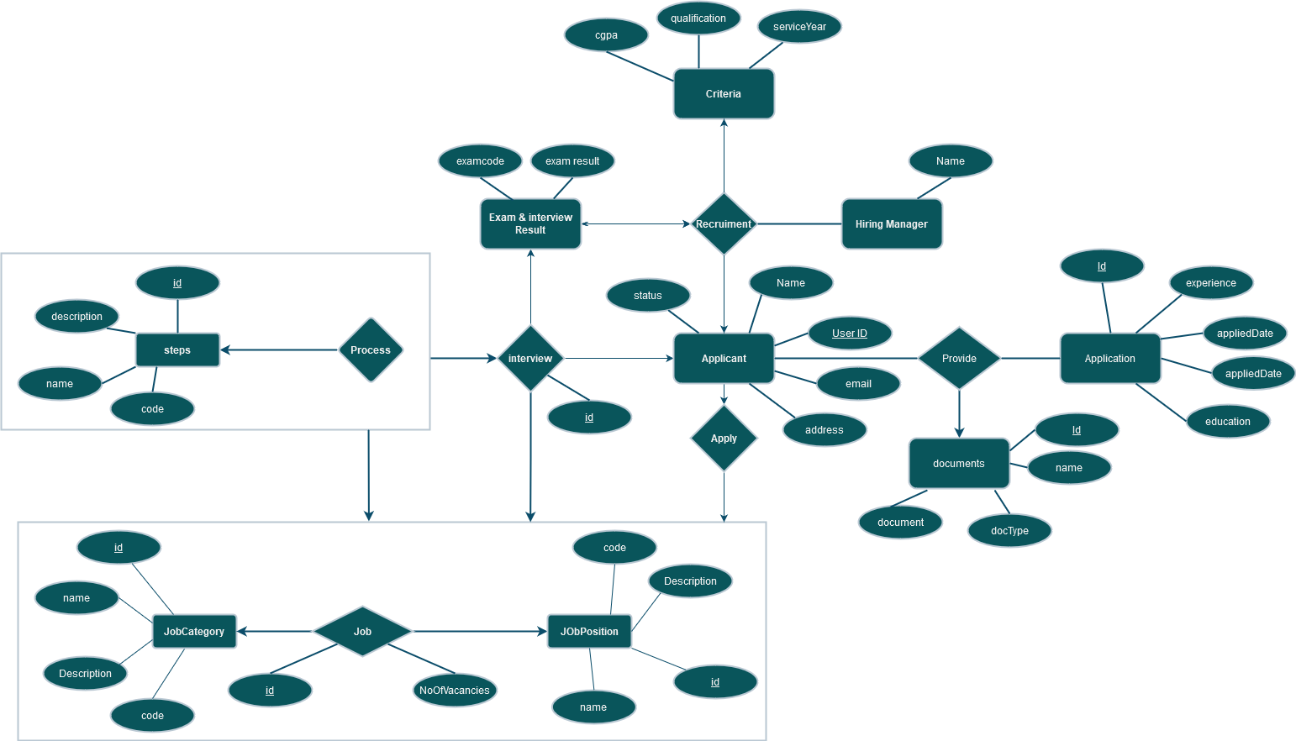

*Figure 6.18 Entity Relationship diagram of Recruitment Management Database*

**6.3.2 Structure of tables in recruitment management system**

The structure of each table of the recruitment management system database are shown in the figures below.

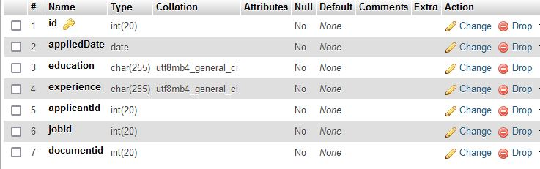

*Figure 6.19 application Table*

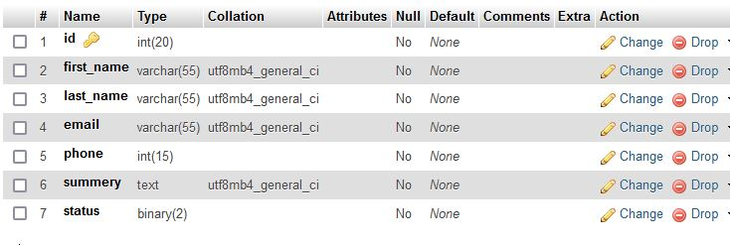

*Figure 6.20 applicant Table*

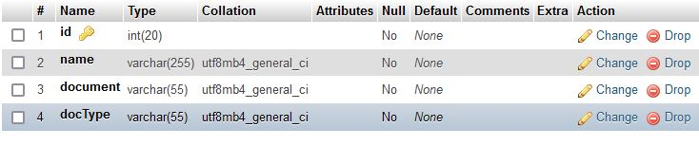

*Figure 6.21 document Table*

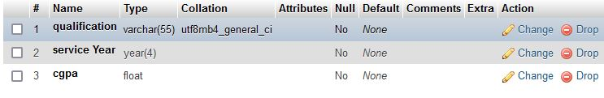

*Figure 6.22 criteria Table*

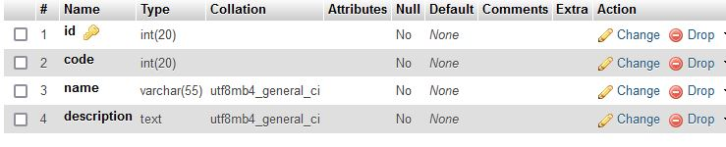

*Figure 6.23 jobcategory Table*

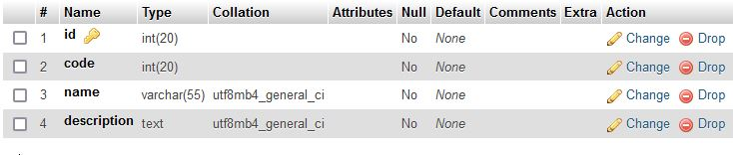

*Figure 6.24 jobposition Table*

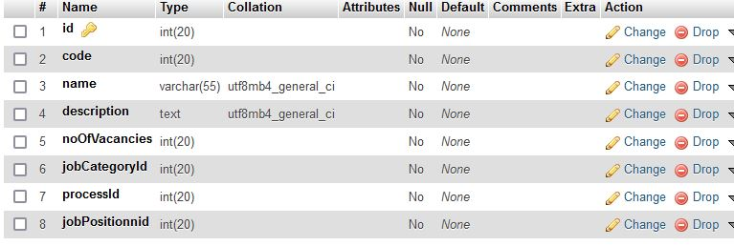

*Figure 6.25 job Table*

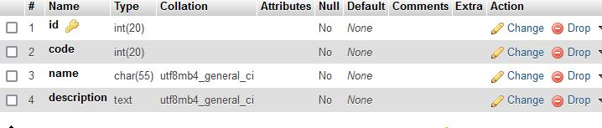

*Figure 6.26 steps Table*

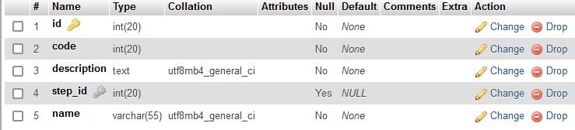

*Figure 6.27 process Table*

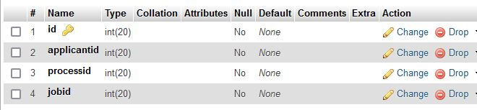

*Figure 6.28 interview Table*

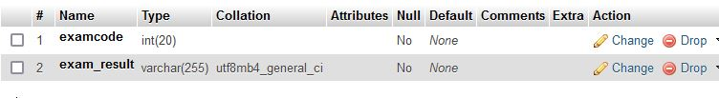

*Figure 6.29 exam&interviewresult Table*

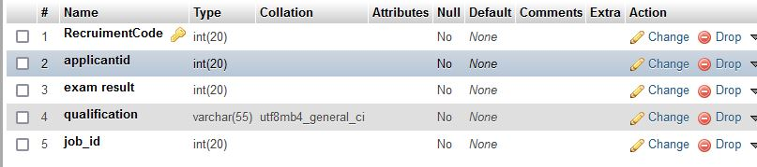

*Figure 6.30 recruitment Table*

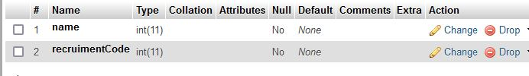

*Figure 6.31 hiring manager Table*

***6.4 Conclusion***

The proposed databases will improve data sharing and data security. This will minimize data inconsistency, faster data access. This will also reduce data entry, storage, and retrieval costs. It will make the Family Planning office more efficient, effective.